Question 1: Student Database Design and Connectivity
Aim
To create an SQLite database containing a Student table, insert student records using Python, and display all the stored records.
Description
This program uses Python's sqlite3 module to connect to an SQLite database. It creates a Student table if it does not already exist, inserts five student records, retrieves all the records using the SELECT statement, and displays them on the screen.
Input
Student details entered into the database:
StudentID | Name | Age | Department | Marks
101 | Rahul | 20 | CSE | 89
102 | Anjali | 19 | ECE | 91
103 | Amit | 21 | AI&DS | 87
104 | Sneha | 20 | IT | 93
105 | Karan | 22 | EEE | 85

Database Connectivity Code
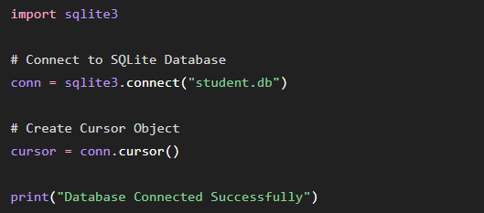
Code
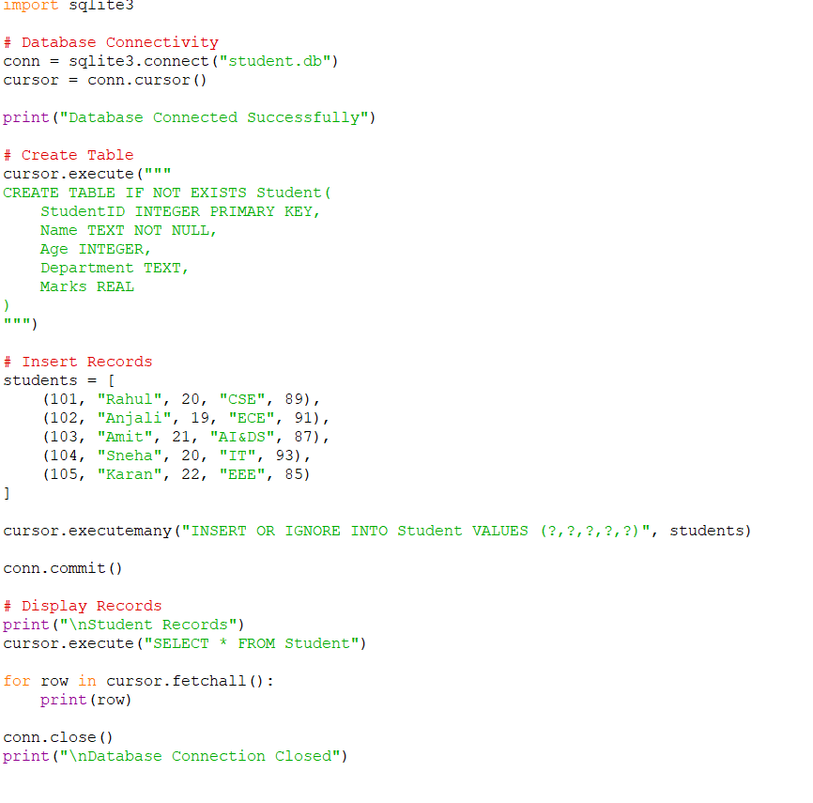
Output
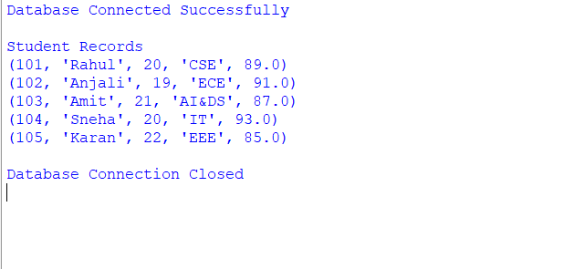

Result
Thus, the SQLite database was successfully created, the Student table was generated, student records were inserted, and all records were displayed successfully.

Question 2: Library Management Database
Aim
To create an SQLite database for library management, insert book details, update the price of a selected book, and display the updated record using Python.
Description
This program creates a Book table in an SQLite database using Python. It inserts sample book records, updates the price of a selected book using the UPDATE statement, and retrieves the updated record using the SELECT statement.
Input
BookID | Title | Author | Publisher | Price
1 | Python Basics | John | Pearson | 450
2 | DBMS | Navathe | McGraw Hill | 650
3 | Java Programming | Herbert | Oracle Press | 550
4 | Data Structures | Seymour | Pearson | 700
5 | AI Fundamentals | Russell | Elsevier | 900
Updated Value:
- Book ID = 4
- New Price = 750
Database Connectivity Code
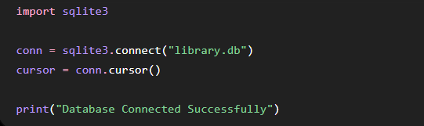
Code
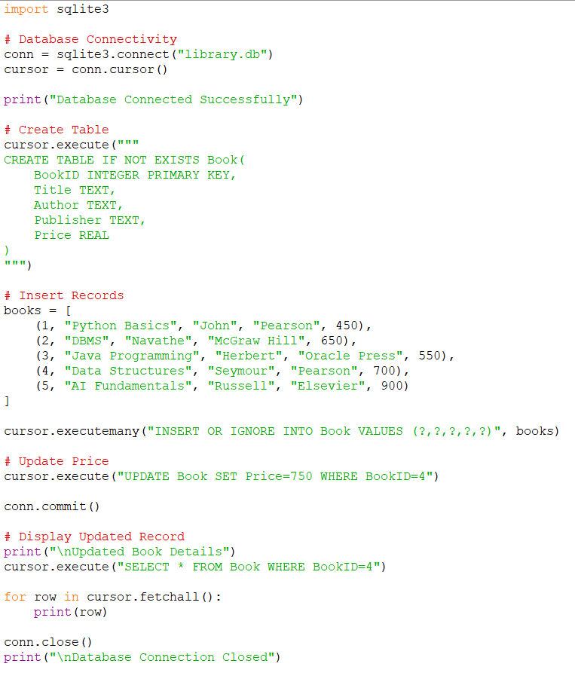
Output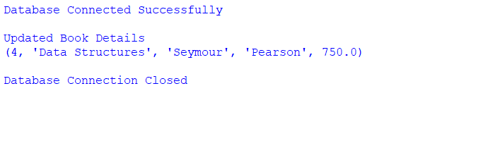

Result
Thus, the SQLite database and Book table were created successfully, the book records were inserted, the selected book price was updated, and the updated information was displayed successfully.

Question 3: Employee and Department Database Design
Aim
To create two related SQLite tables (Department and Employee), insert sample records, and display employee names along with their department names using an SQL JOIN query.
Description
This program creates Department and Employee tables with a Primary Key–Foreign Key relationship. Sample records are inserted into both tables. An SQL JOIN query is used to retrieve and display each employee along with the corresponding department name.
Input
Department Table
DeptID | DeptName
1 | HR
2 | Finance
3 | IT
4 | Marketing

Employee Table
EmpID | EmpName | Salary | DeptID
101 | Rahul | 45000 | 3
102 | Anjali | 50000 | 2
103 | Sneha | 55000 | 1
104 | Karan | 47000 | 4
105 | Amit | 60000 | 3

Database Connectivity Code
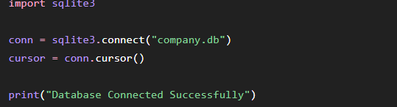
Code
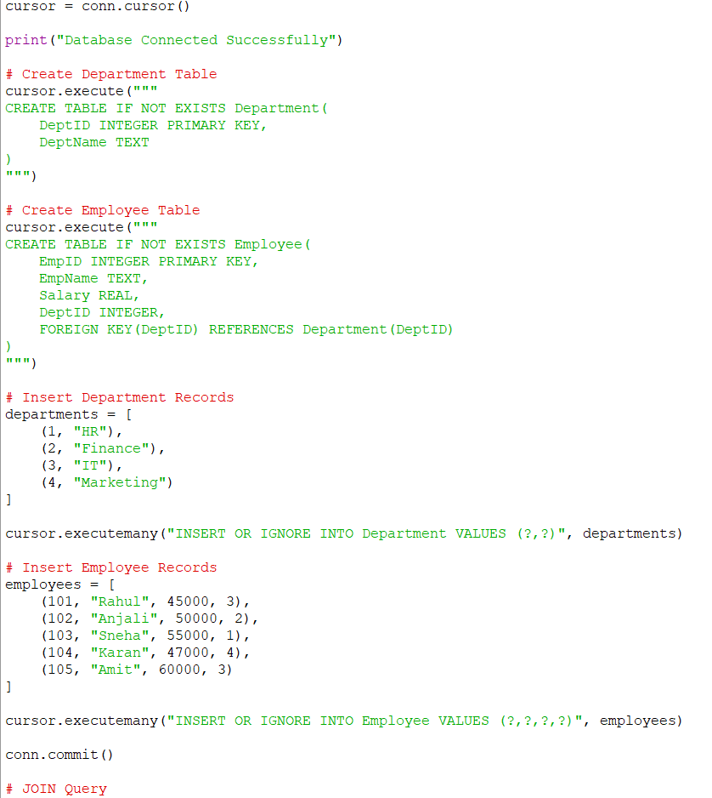
Output
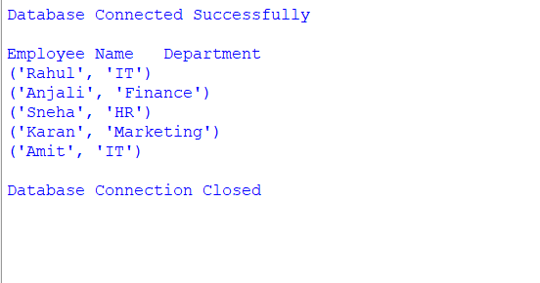
Result :
Thus, the Department and Employee tables were successfully created with a Primary Key–Foreign Key relationship, sample records were inserted, and the employee details along with their corresponding department names were displayed successfully using an SQL JOIN operation.

